1. **Create a database named employee, then import data_science_team.csv proj_table.csv and emp_record_table.csv into the employee database from the given resources.**

**Query –**

CREATE database employee;

**Output –**

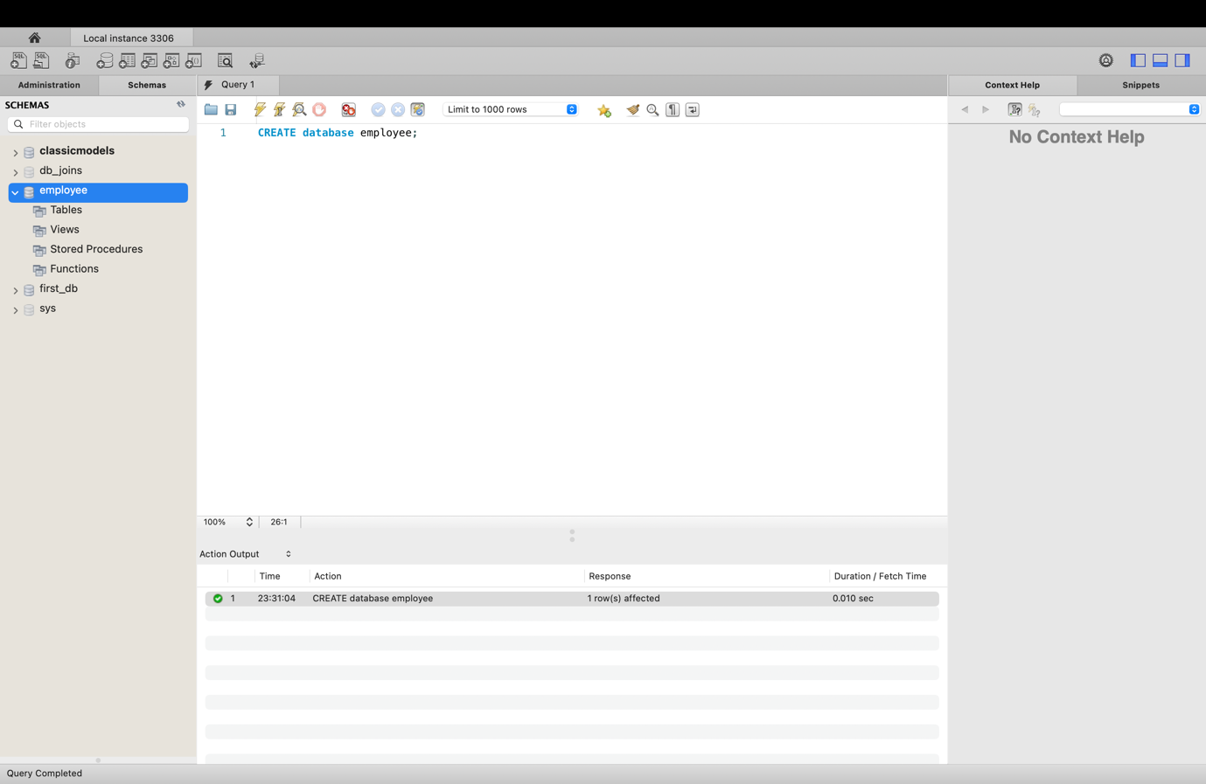

Use employee;

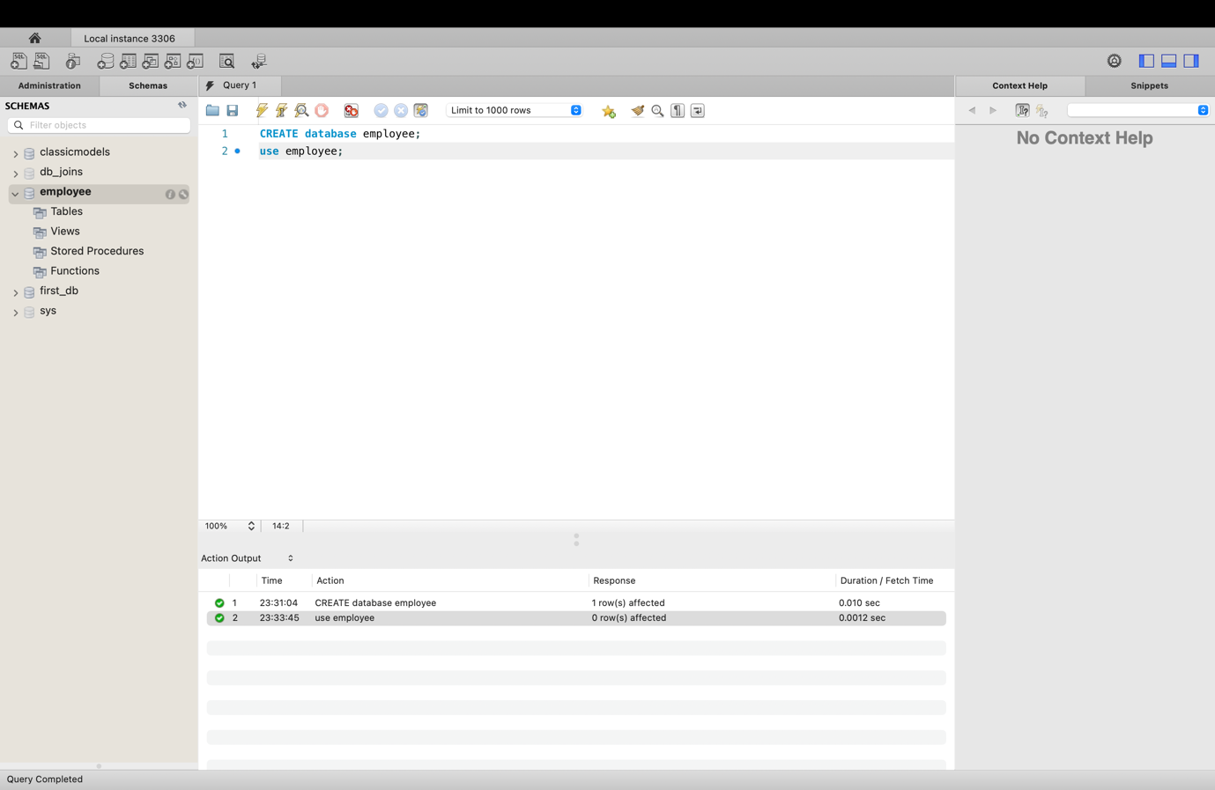

import data_science_team.csv proj_table.csv and emp_record_table.csv into the employee database.

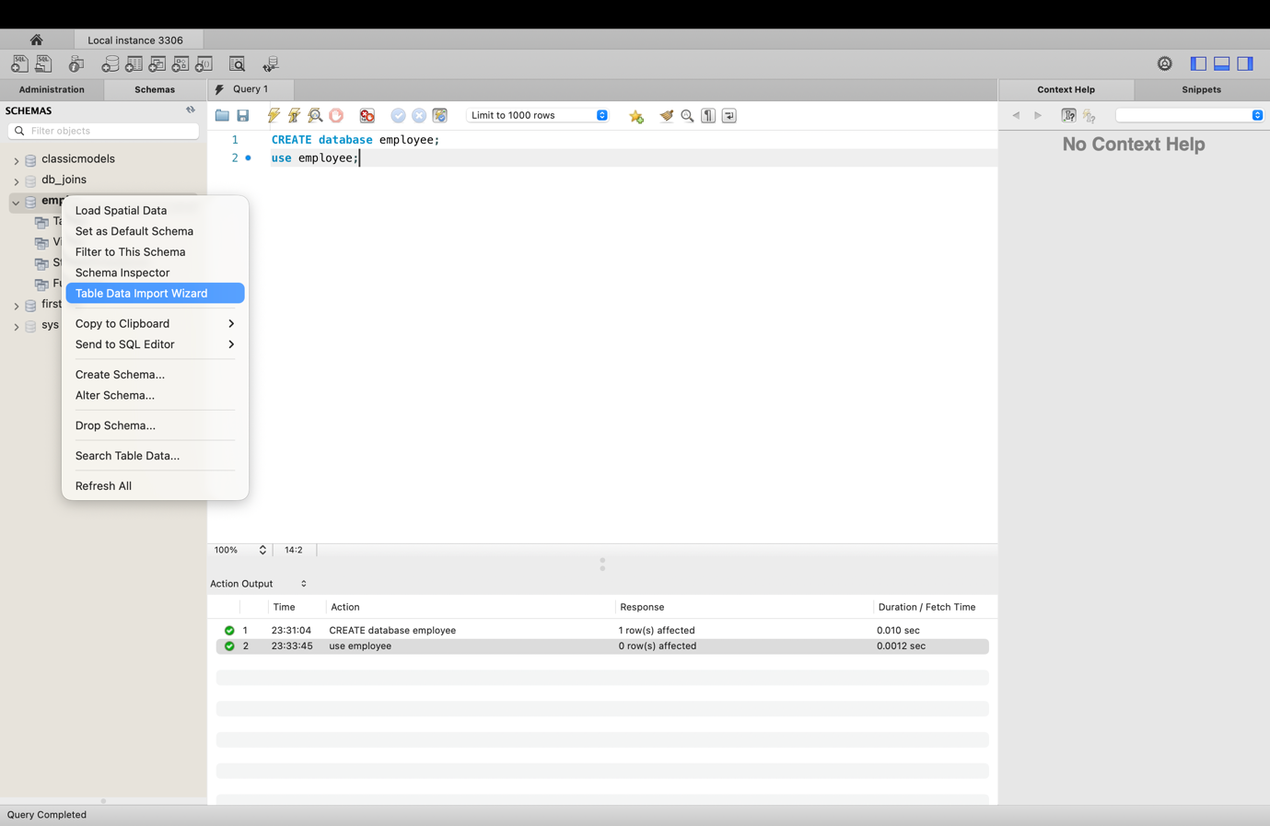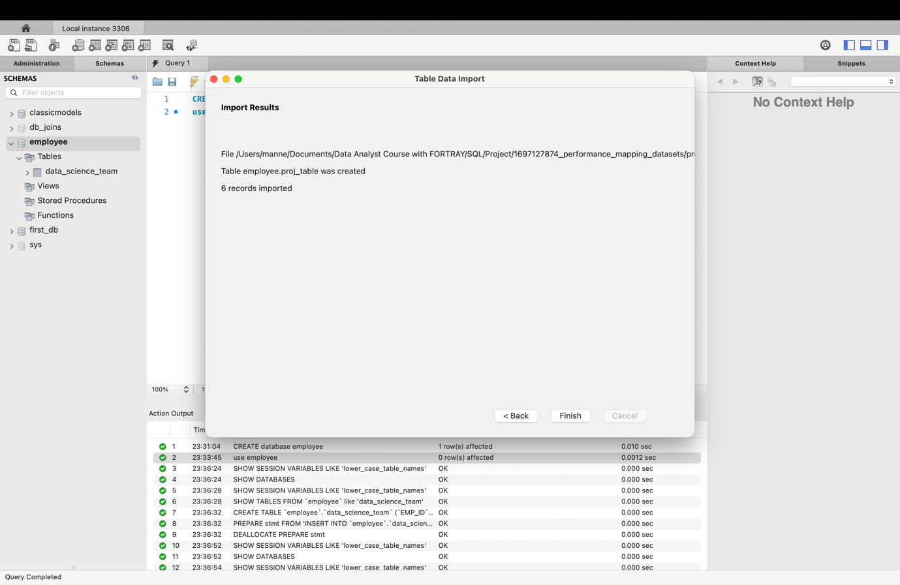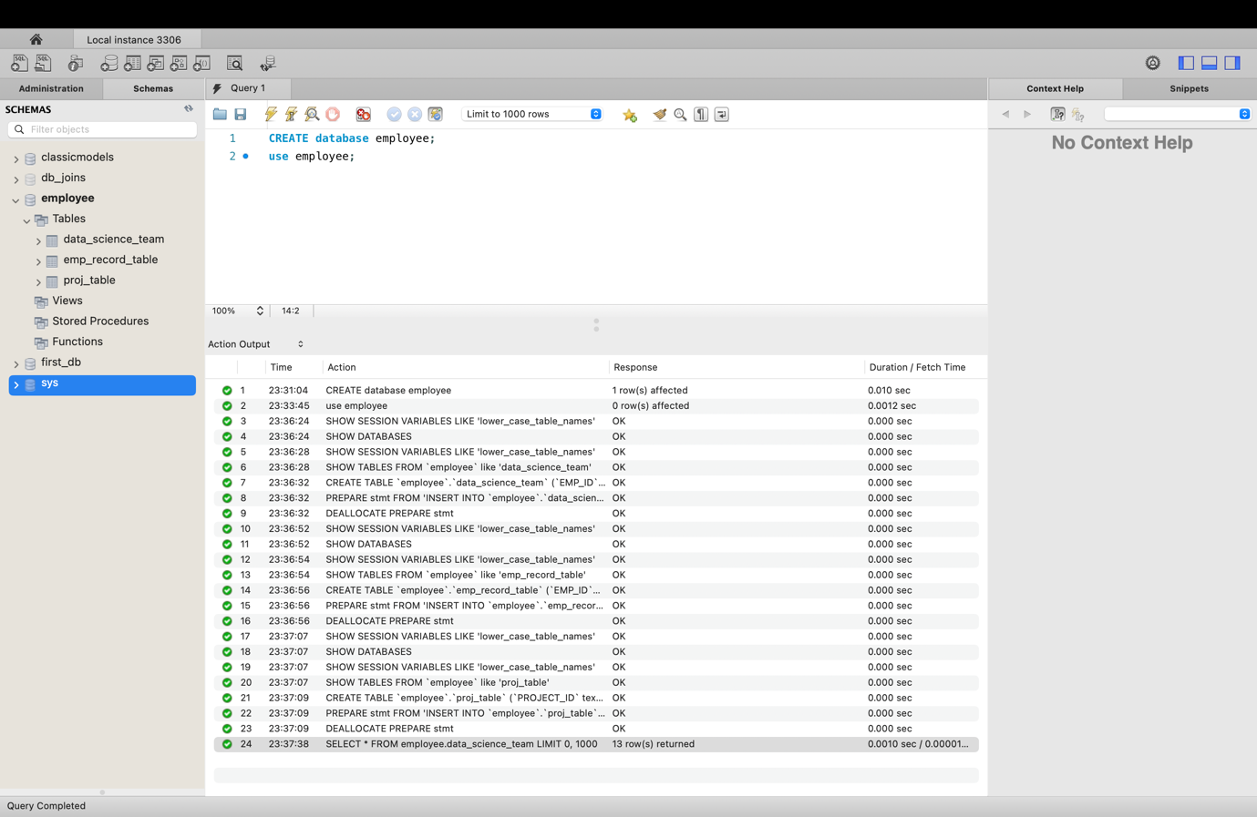

1. **Create an ER diagram for the given employee database.**

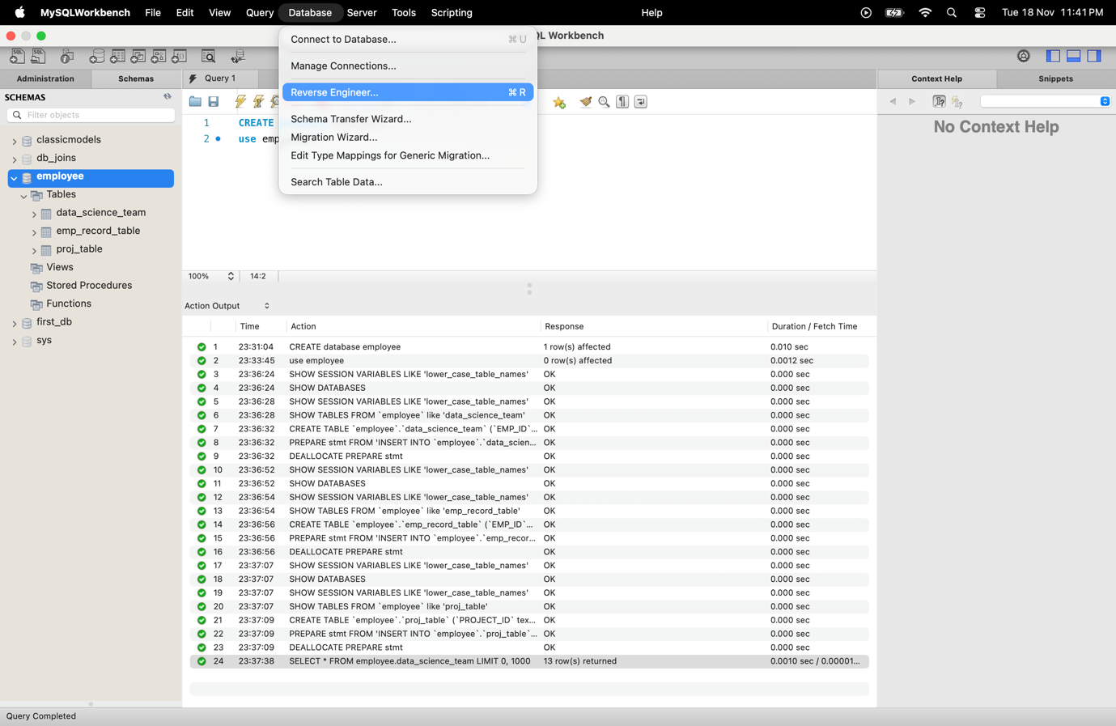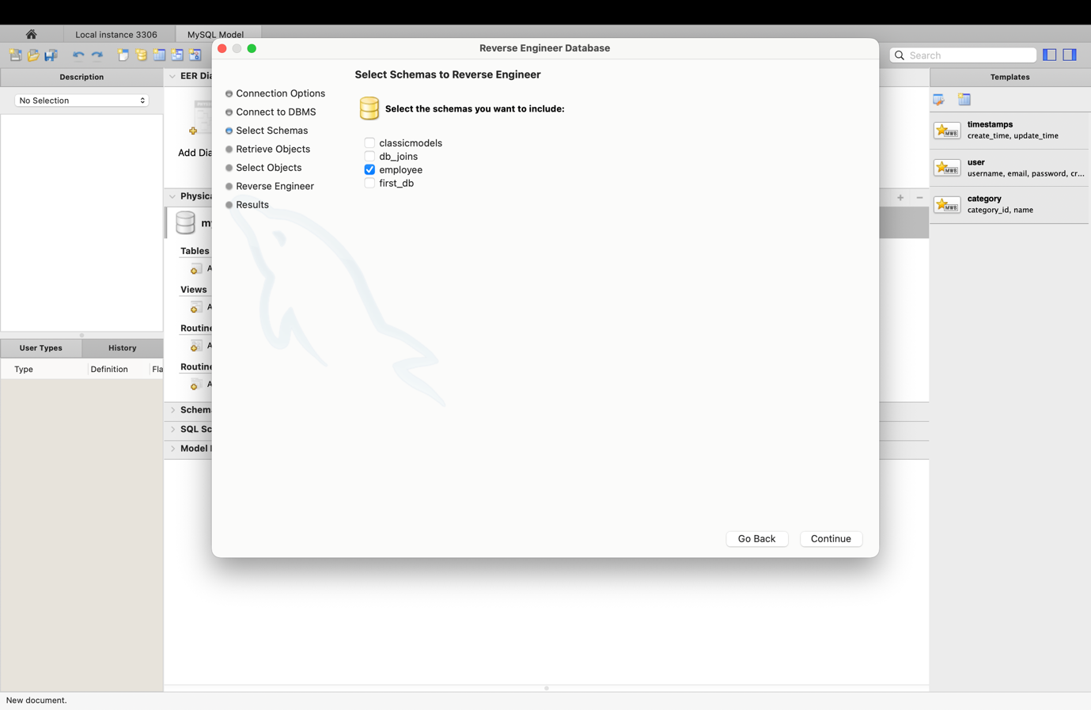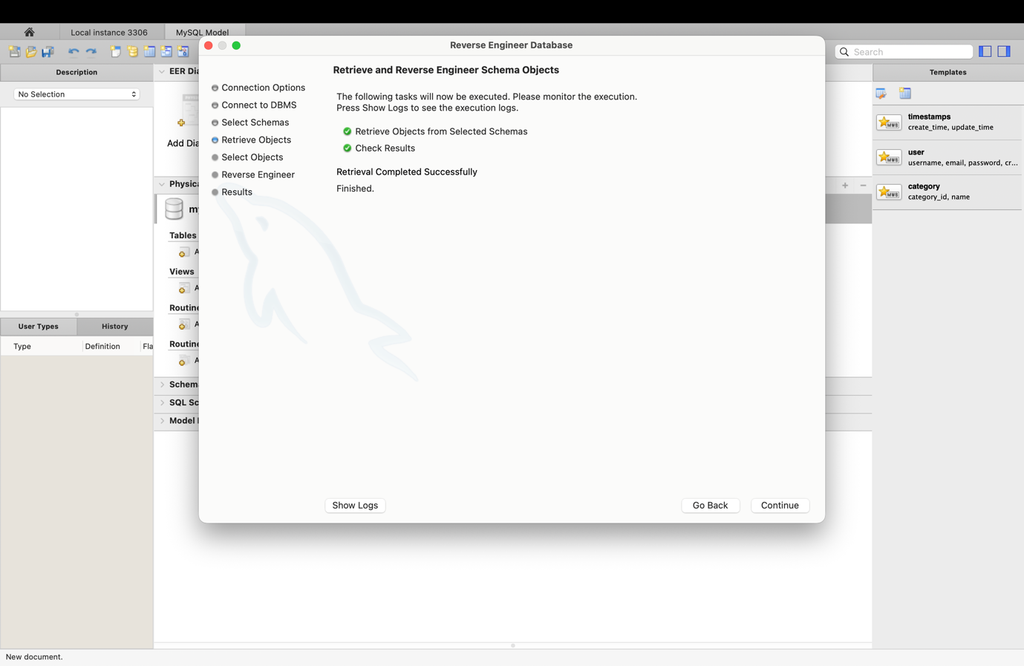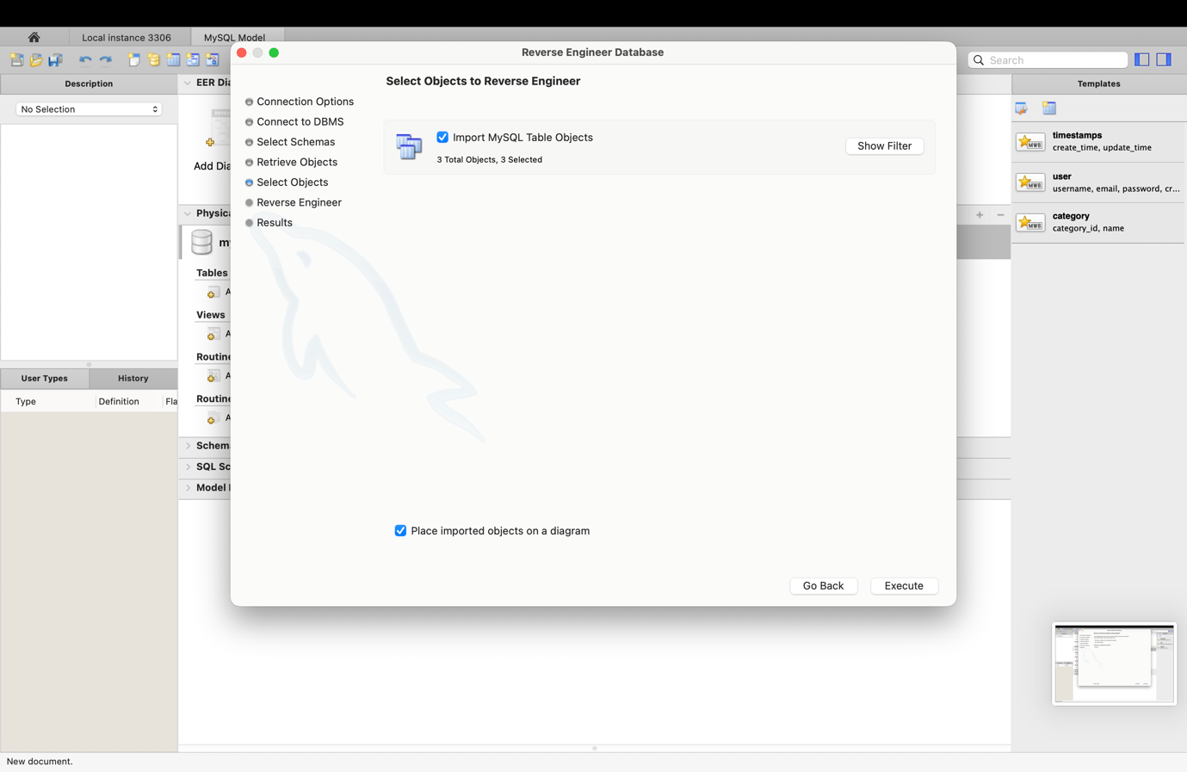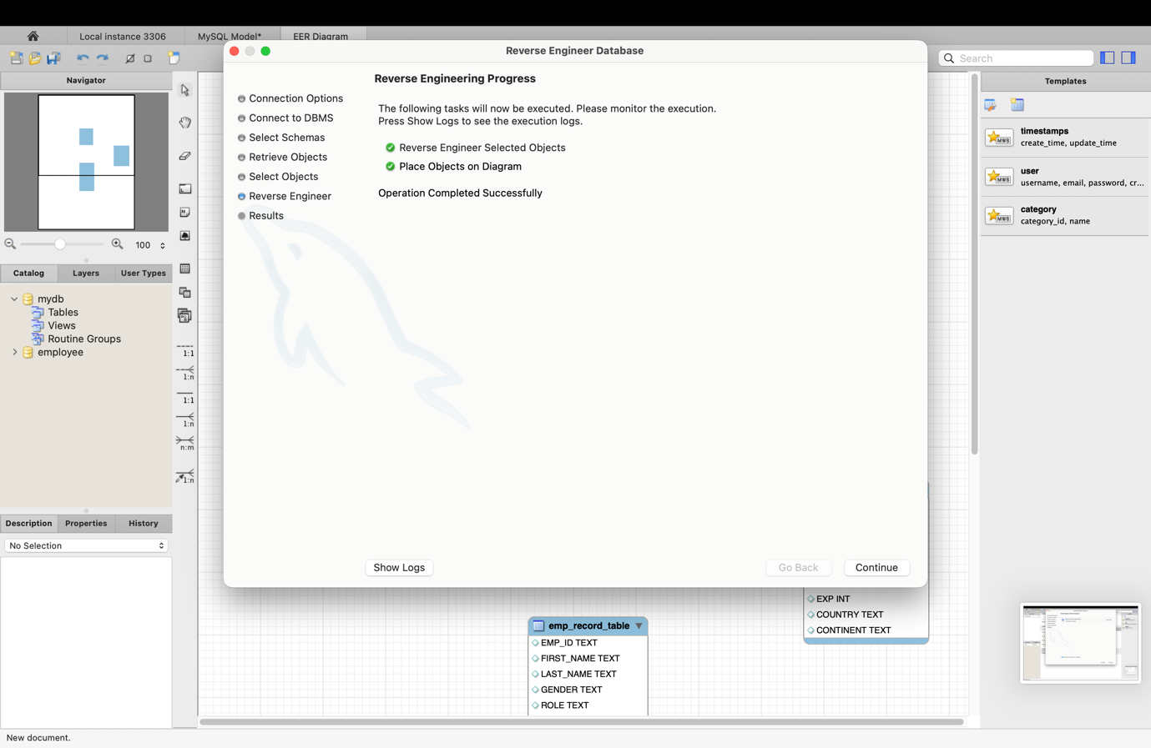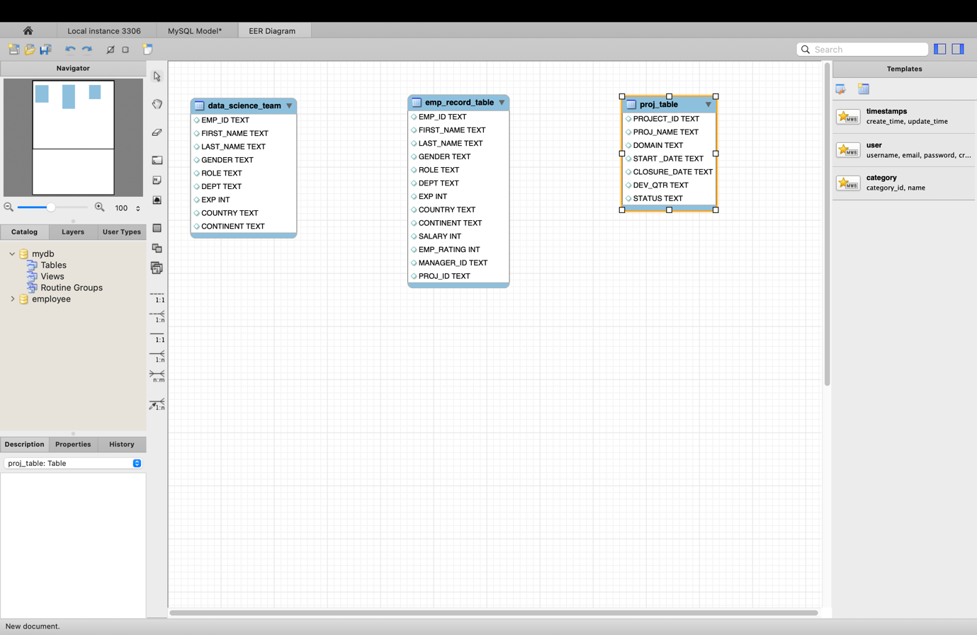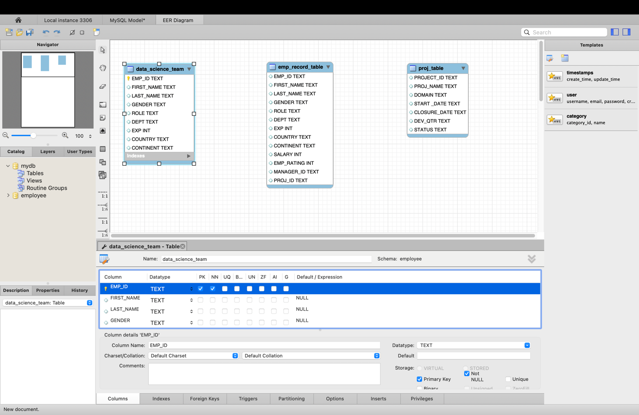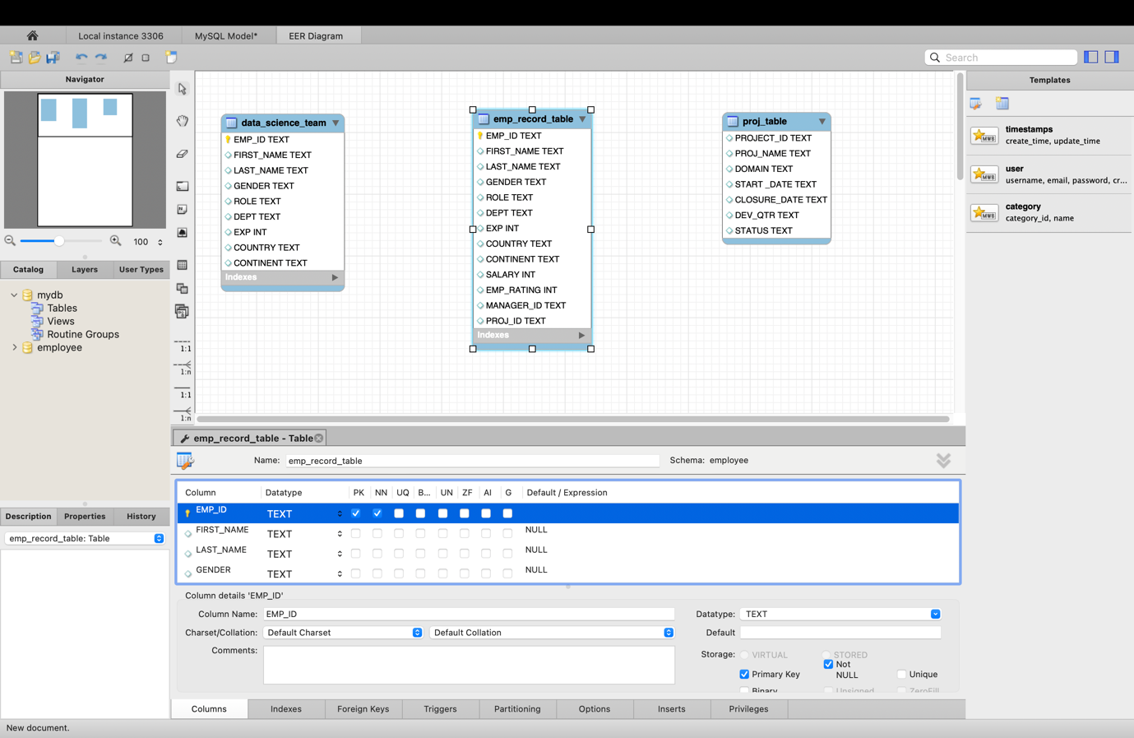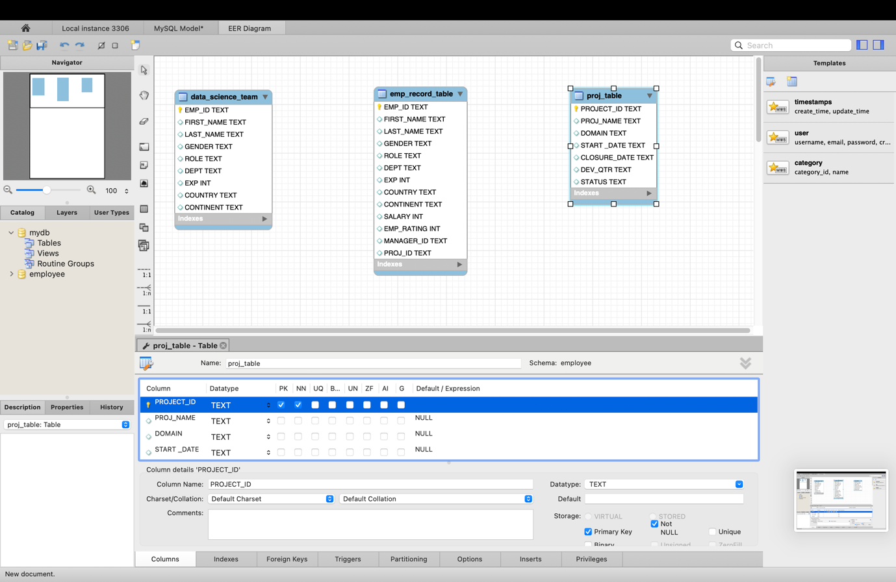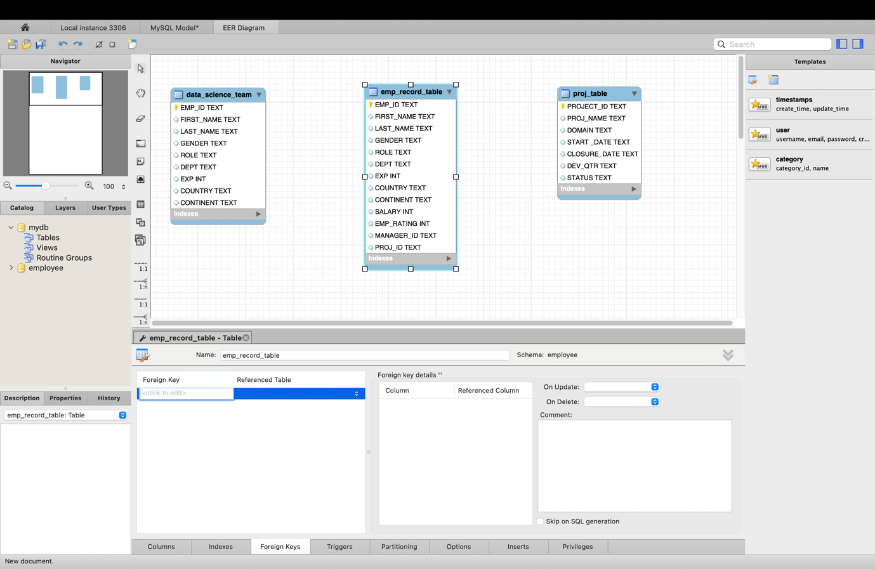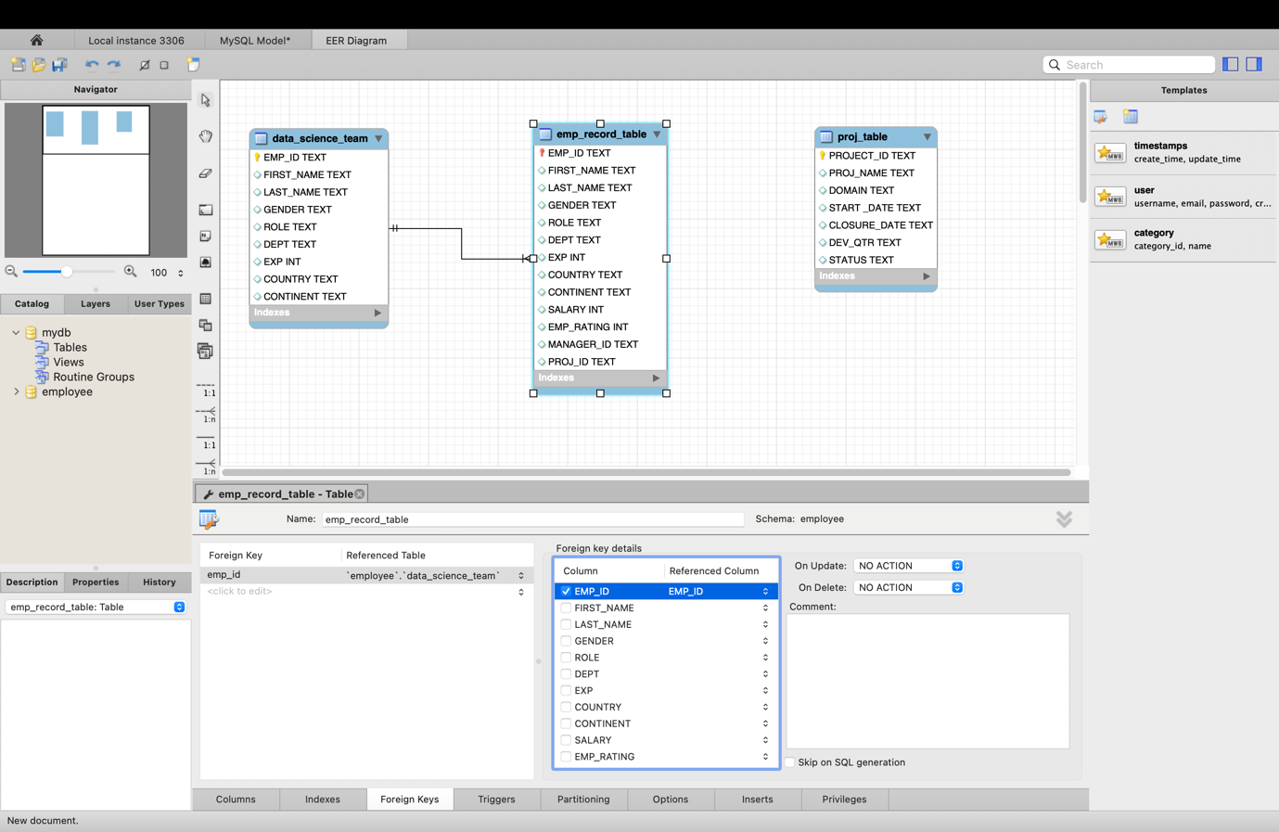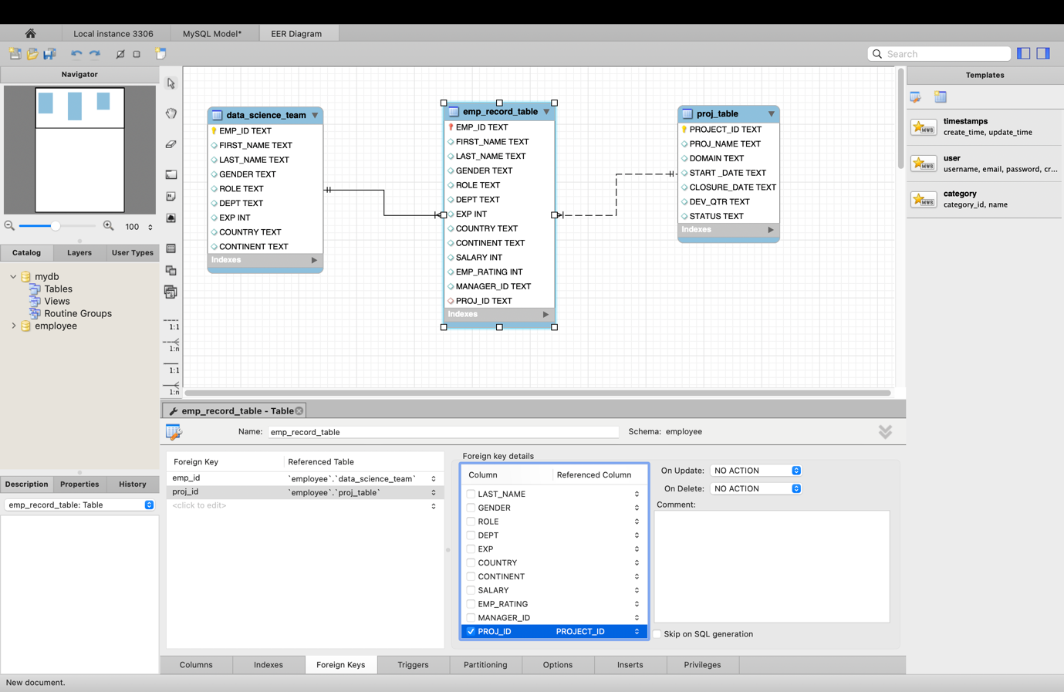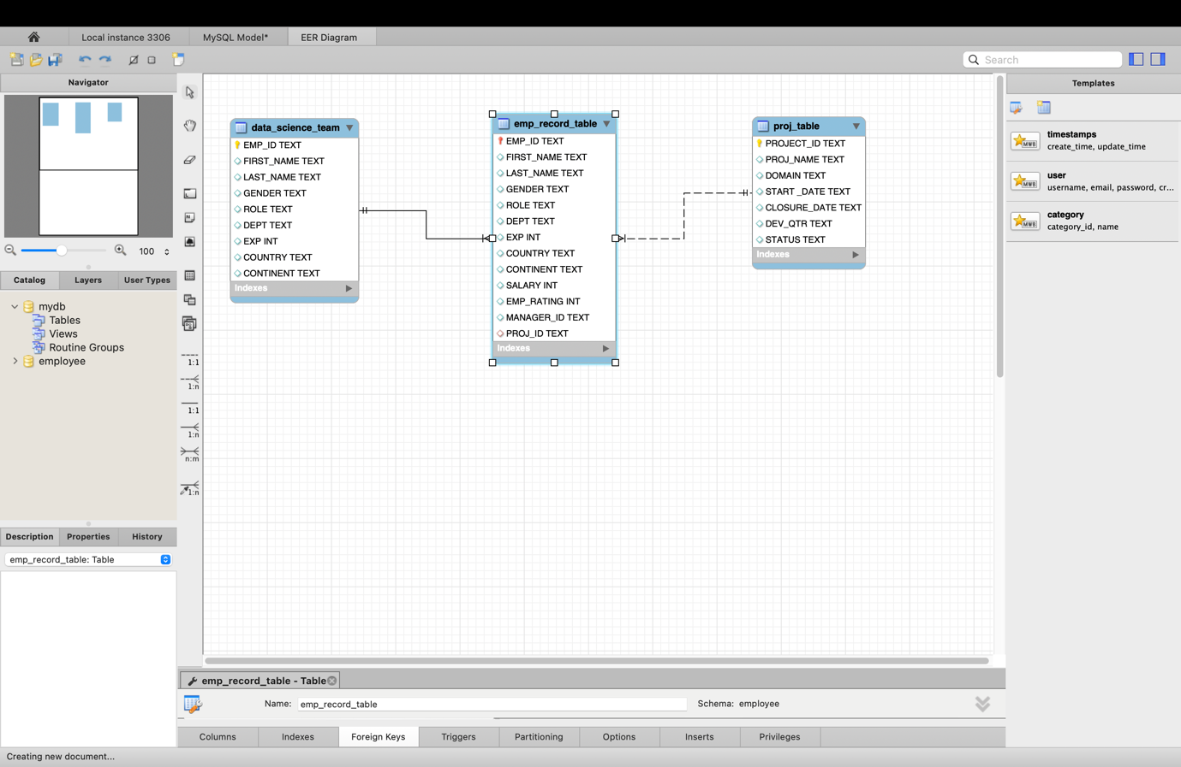

1. **Write a query to fetch EMP_ID, FIRST_NAME, LAST_NAME, GENDER, and DEPARTMENT from the employee record table, and make a list of employees and details of their department.**

**QUERY –**

Select EMP_ID, FIRST_NAME, LAST_NAME, GENDER, DEPT from emp_record_table;

**OUTPUT –**

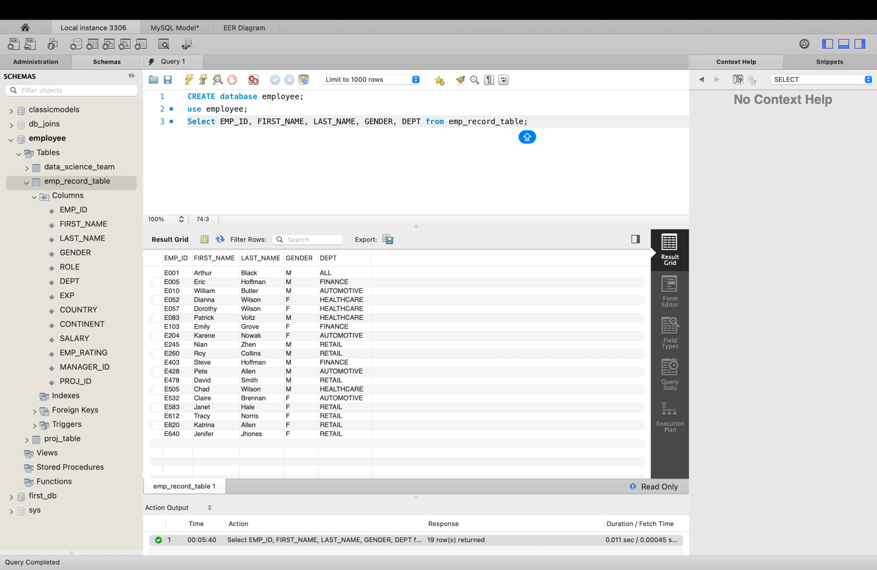

1. **Write a query to fetch EMP_ID, FIRST_NAME, LAST_NAME, GENDER, DEPARTMENT, and EMP_RATING if the EMP_RATING is:**

* **less than two**
* **greater than four**
* **between two and four**

**QUERY –**

SELECT

EMP_ID, FIRST_NAME, LAST_NAME, GENDER, DEPT, EMP_RATING

FROM

emp_record_table

WHERE

EMP_RATING < 2

OR EMP_RATING BETWEEN 2 AND 4

OR EMP_RATING > 4;

**OUTPUT –**

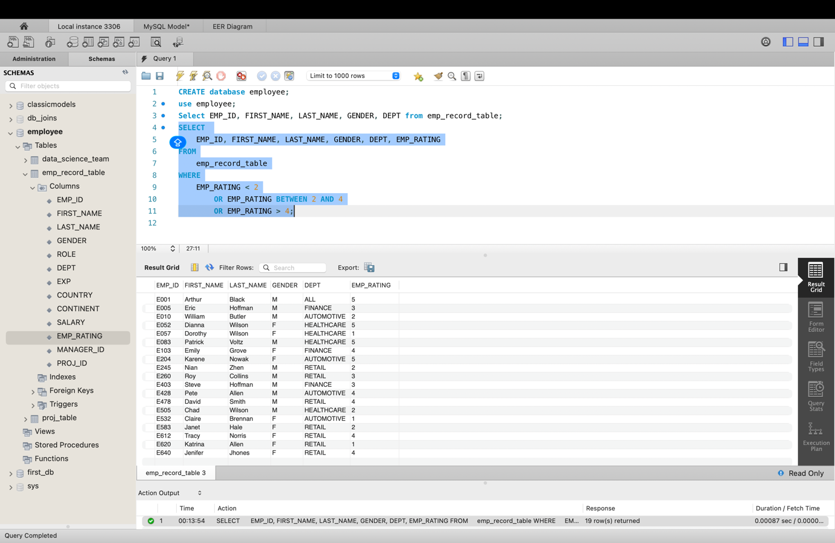

1. **Write a query to concatenate the FIRST_NAME and the LAST_NAME of employees in the Finance department from the employee table and then give the resultant column alias as NAME.**

**QUERY –**

SELECT

EMP_ID,

FIRST_NAME,

LAST_NAME,

DEPT,

CONCAT(TRIM(FIRST_NAME), ' ', TRIM(LAST_NAME)) AS 'NAME'

FROM

emp_record_table

WHERE

DEPT = 'FINANCE';

**OUTPUT –**

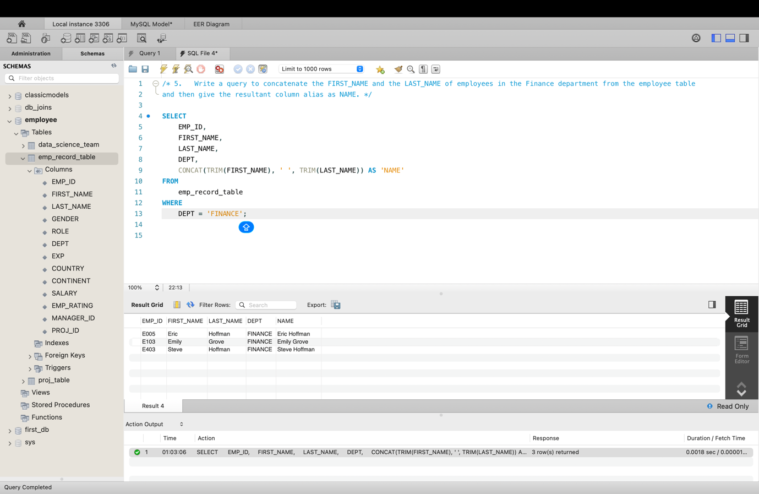

1. **Write a query to list only those employees who have someone reporting to them. Also, show the number of reporters (including the President).**

**QUERY –**

SELECT

m.EMP_ID AS ManagerID,

CONCAT(m.FIRST_NAME, ' ', m.LAST_NAME) AS ManagerName,

COUNT(e.EMP_ID) AS NumberOfReporters

FROM

emp_record_table m

JOIN

emp_record_table e ON m.EMP_ID = e.MANAGER_ID

GROUP BY m.EMP_ID , m.FIRST_NAME , m.LAST_NAME;

**OUTPUT –**

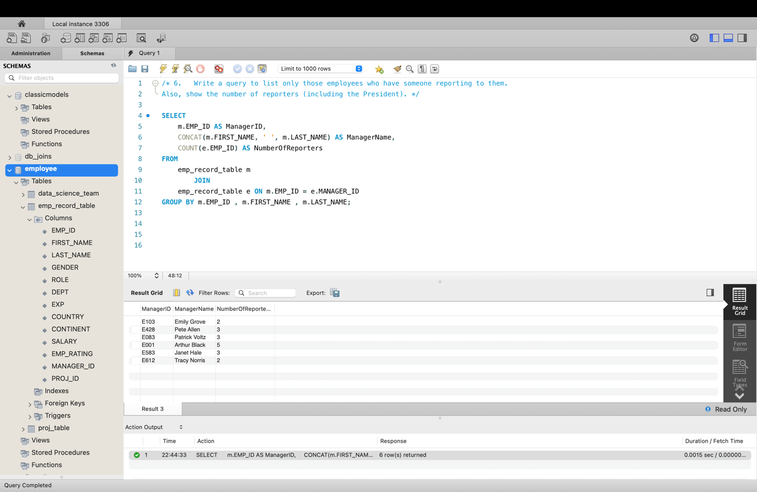

1. **Write a query to list down all the employees from the healthcare and finance departments using union. Take data from the employee record table.**

**QUERY –**

SELECT

*

FROM

emp_record_table

WHERE

DEPT = 'HEALTHCARE'

UNION SELECT

*

FROM

emp_record_table

WHERE

DEPT = 'FINANCE';

**OUTPUT –**

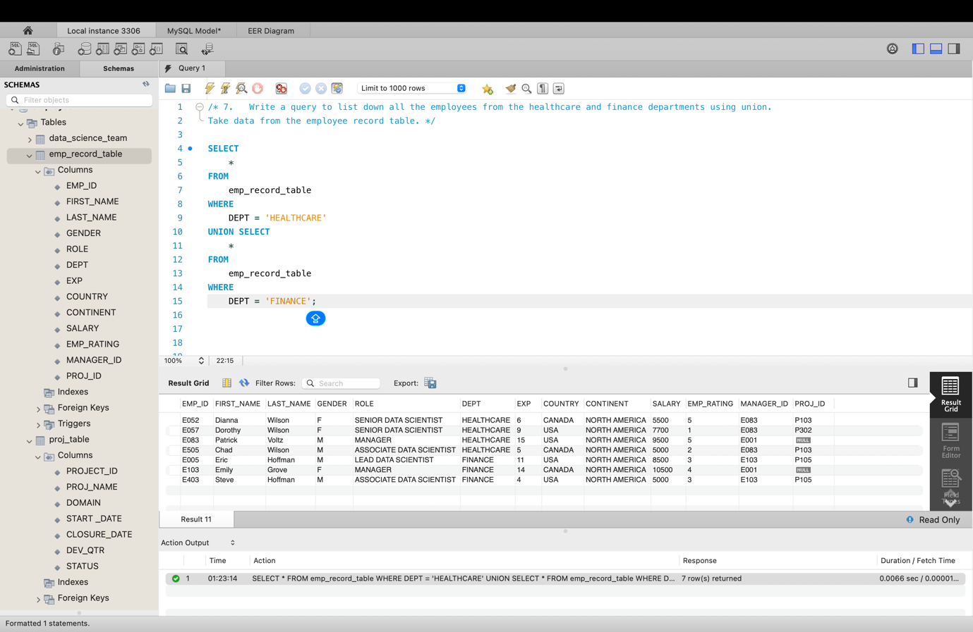

1. **Write a query to list down employee details such as EMP_ID, FIRST_NAME, LAST_NAME, ROLE, DEPARTMENT, and EMP_RATING grouped by dept. Also include the respective employee rating along with the max emp rating for the department.**

**Query –**

SELECT

EMP_ID,

FIRST_NAME,

LAST_NAME,

ROLE,

DEPT,

EMP_RATING,

MAX(EMP_RATING) OVER (PARTITION BY DEPT) AS Max_Dept_Rating

FROM emp_record_table

GROUP BY

EMP_ID, FIRST_NAME, LAST_NAME, ROLE, DEPT, EMP_RATING

ORDER BY DEPT, EMP_RATING DESC;

**Output –**

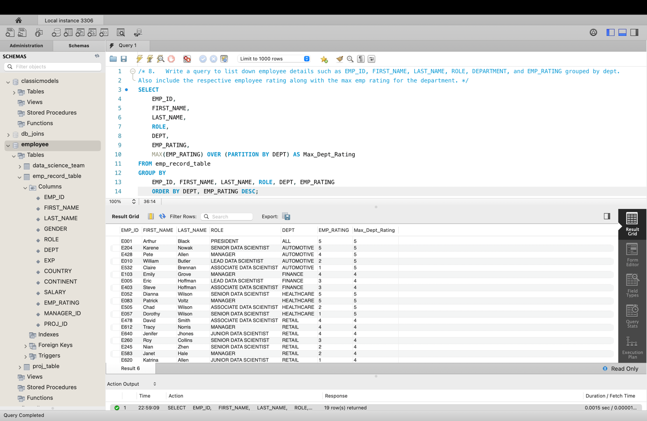

1. **Write a query to calculate the minimum and the maximum salary of the employees in each role. Take data from the employee record table.**

**Query –**

SELECT

EMP_ID,

ROLE,

SALARY,

MIN(SALARY) OVER (PARTITION BY role) AS Min_Salary,

MAX(SALARY) OVER (PARTITION BY role) AS Max_Salary

FROM

emp_record_table;

**Output -**

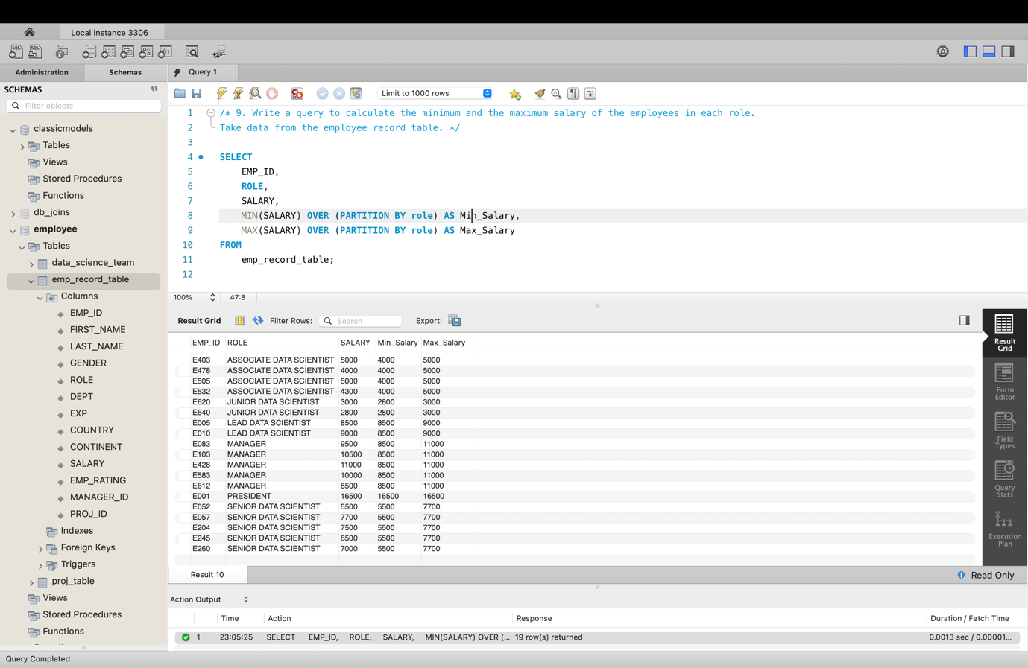

1. **Write a query to assign ranks to each employee based on their experience. Take data from the employee record table.**

**Query –**

SELECT

EMP_ID,

CONCAT(TRIM(FIRST_NAME), ' ', TRIM(LAST_NAME)) AS 'Full_Name' ,

EXP,

RANK() OVER (ORDER BY EXP DESC) AS Experience_Rank

FROM

emp_record_table;

**Output –**

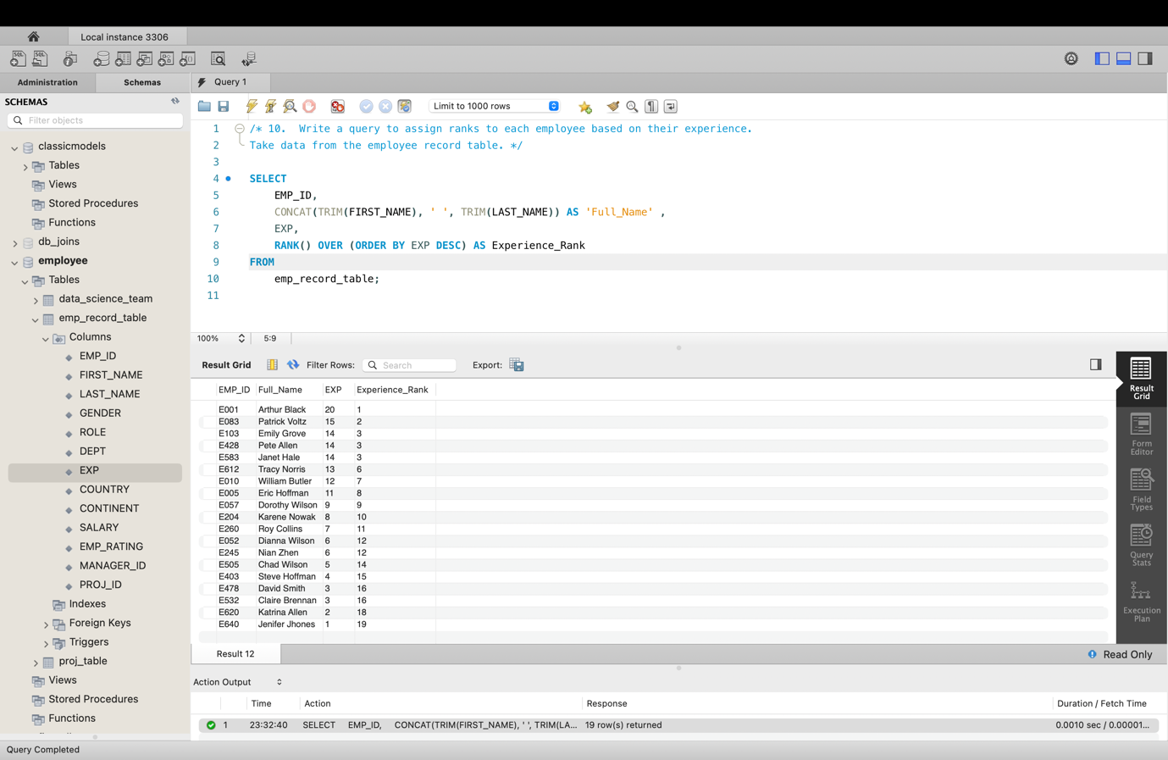

1. **Write a query to create a view that displays employees in various countries whose salary is more than six thousand. Take data from the employee record table.**

**Query –**

CREATE VIEW Employees_View AS

SELECT

emp_id, first_name, last_name, country, salary

FROM

emp_record_table

WHERE

salary > 6000

ORDER BY country;

**Output –**

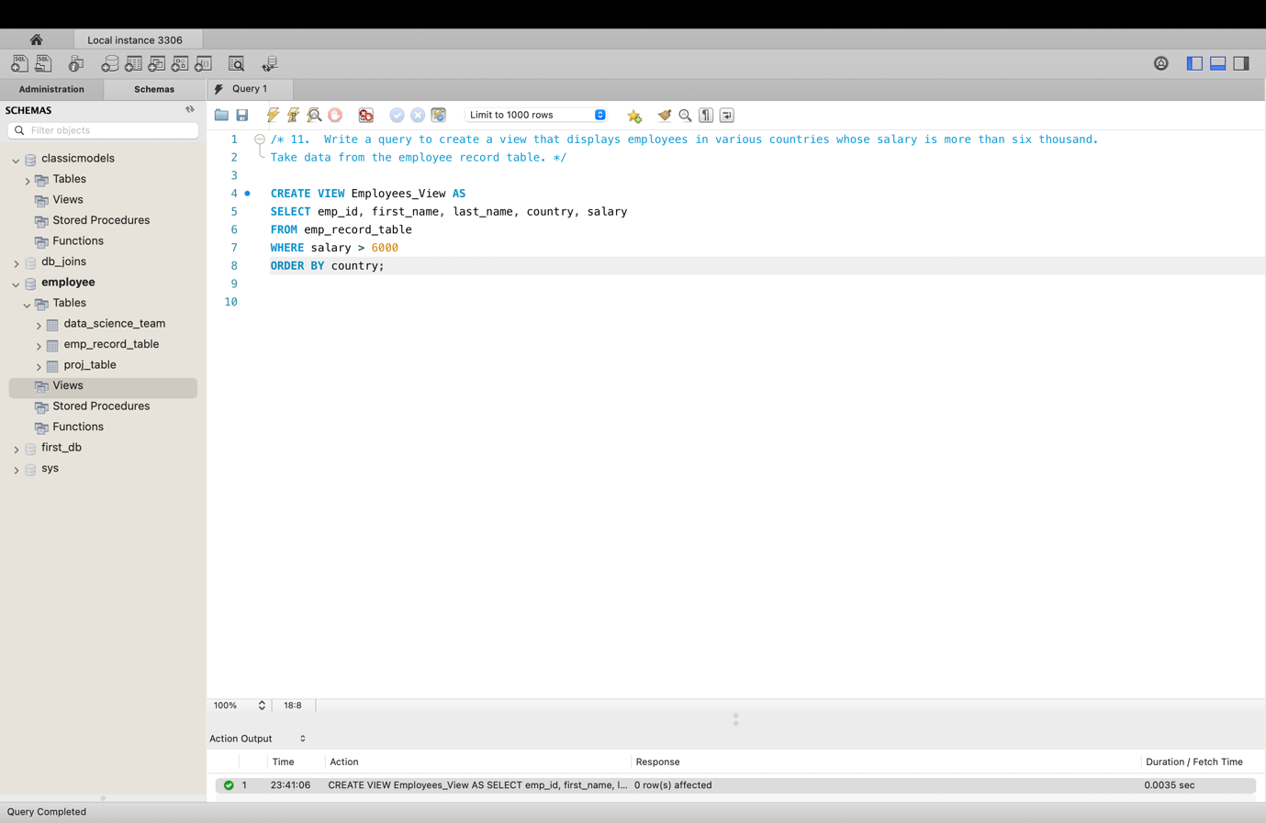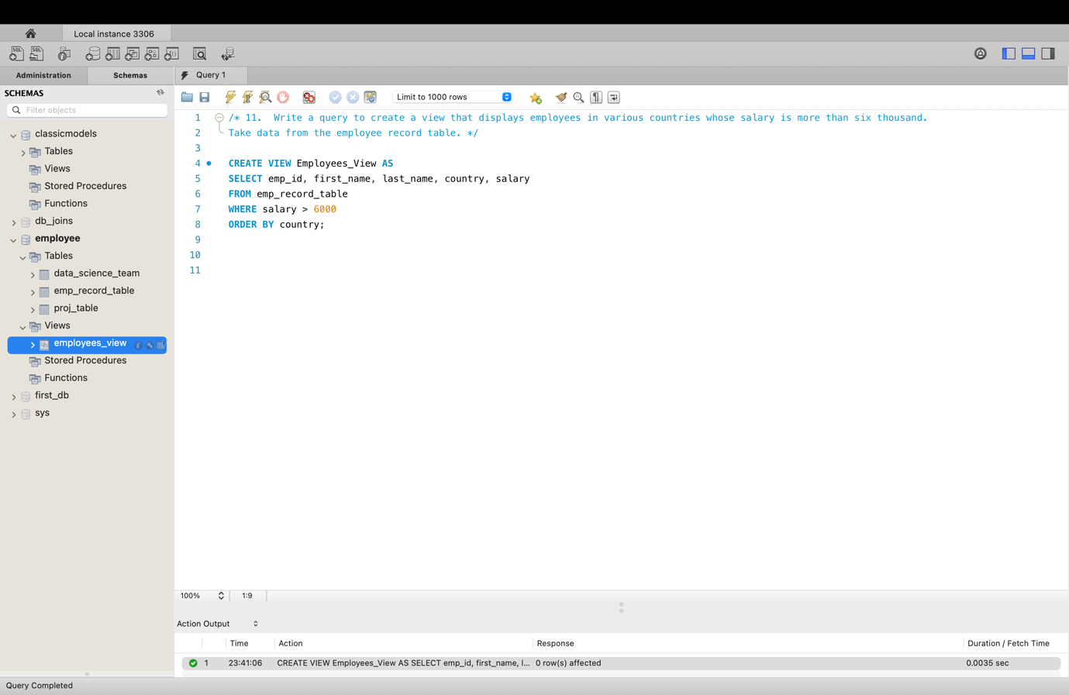

select * from employees_view;

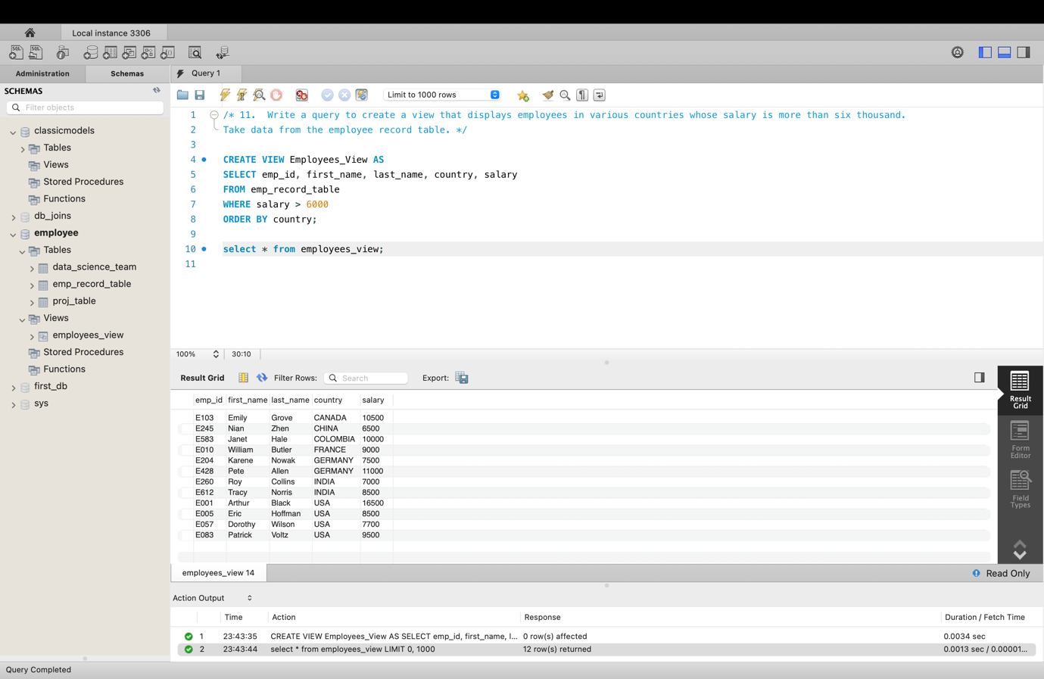

1. **Write a nested query to find employees with experience of more than ten years. Take data from the employee record table.**

**Query –**

SELECT

*

FROM

emp_record_table

WHERE

EXP > (SELECT 10);

**Output –**

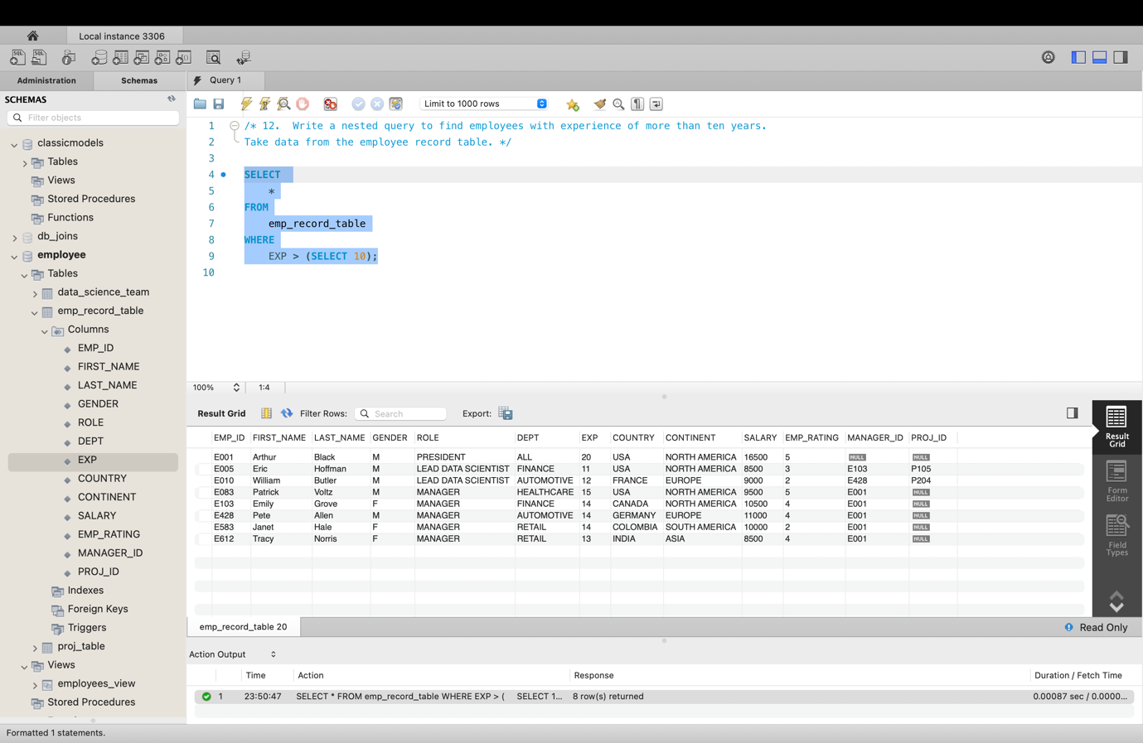

1. **Write a query to create a stored procedure to retrieve the details of the employees whose experience is more than three years. Take data from the employee record table.**

**Query –**

DELIMITER //

CREATE PROCEDURE Experienced_Employees()

BEGIN

SELECT *

FROM emp_record_table

WHERE EXP > 3;

END //

DELIMITER ;

**Output –**

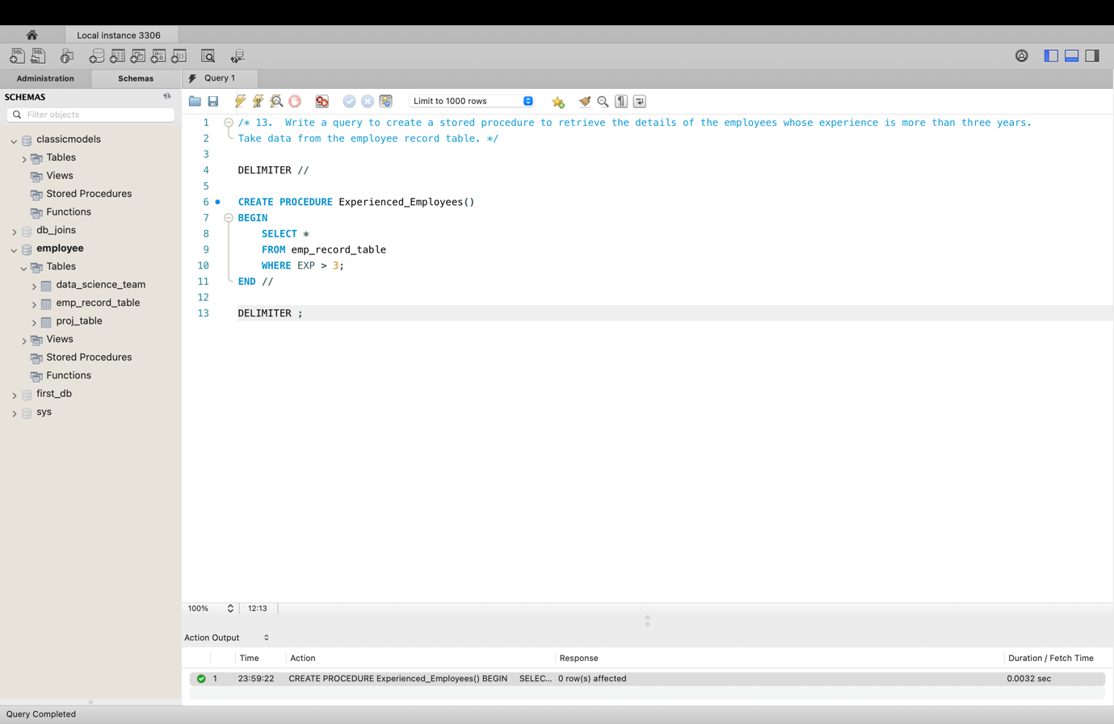

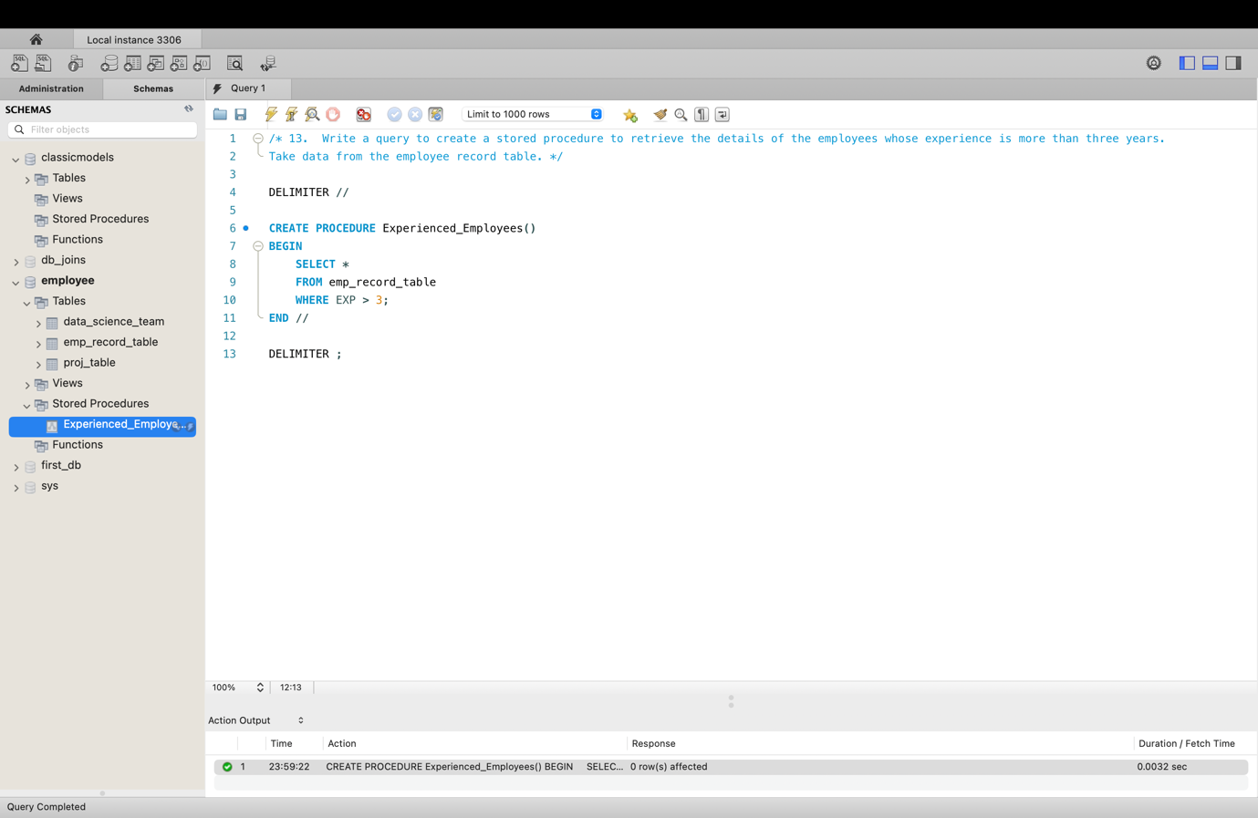

call Experienced_Employees();

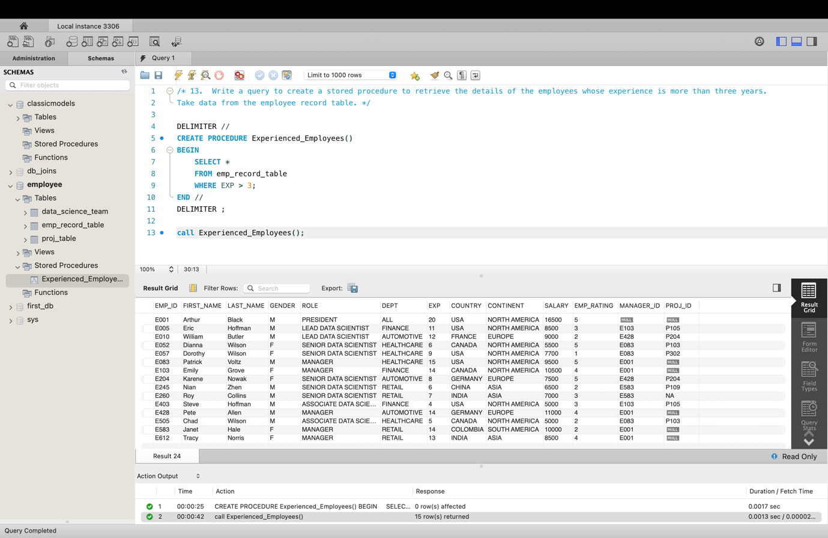

1. **Write a query using stored functions in the project table to check whether the job profile assigned to each employee in the data science team matches the organization’s set standard.**

**The standard being:**

**For an employee with experience less than or equal to 2 years assign 'JUNIOR DATA SCIENTIST',**

**For an employee with the experience of 2 to 5 years assign 'ASSOCIATE DATA SCIENTIST',**

**For an employee with the experience of 5 to 10 years assign 'SENIOR DATA SCIENTIST',**

**For an employee with the experience of 10 to 12 years assign 'LEAD DATA SCIENTIST',**

**For an employee with the experience of 12 to 16 years assign 'MANAGER'.**

**Query –**

DELIMITER $$

CREATE FUNCTION Job_Profile(EXP INT)

RETURNS VARCHAR(50)

DETERMINISTIC

BEGIN

DECLARE ROLE VARCHAR(50);

IF EXP <= 2 THEN

SET ROLE = 'JUNIOR DATA SCIENTIST';

ELSEIF EXP > 2 AND EXP <= 5 THEN

SET ROLE = 'ASSOCIATE DATA SCIENTIST';

ELSEIF EXP > 5 AND EXP <= 10 THEN

SET ROLE = 'SENIOR DATA SCIENTIST';

ELSEIF EXP > 10 AND EXP <= 12 THEN

SET ROLE = 'LEAD DATA SCIENTIST';

ELSEIF EXP > 12 AND EXP <= 16 THEN

SET ROLE = 'MANAGER';

END IF;

RETURN ROLE;

END $$

DELIMITER ;

**Output –**

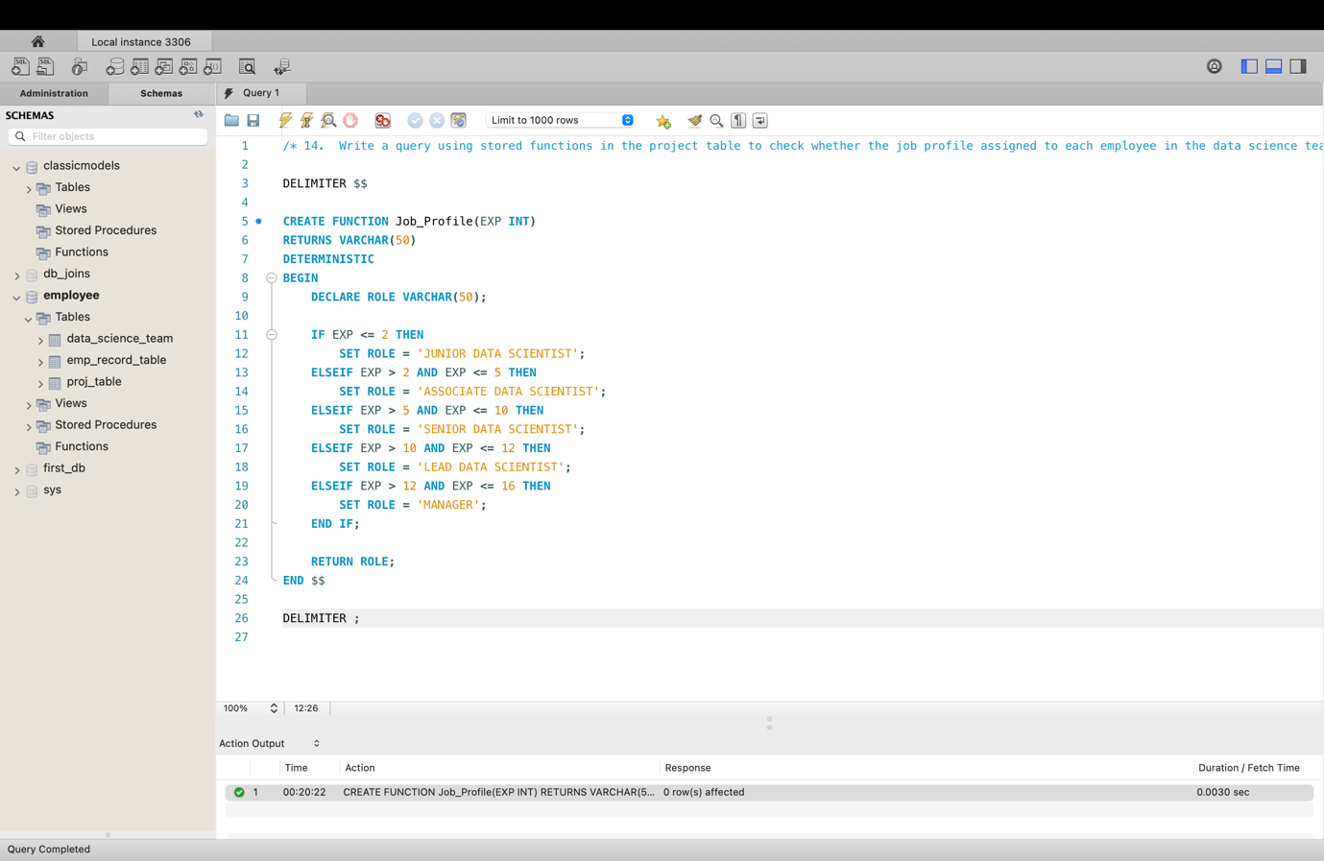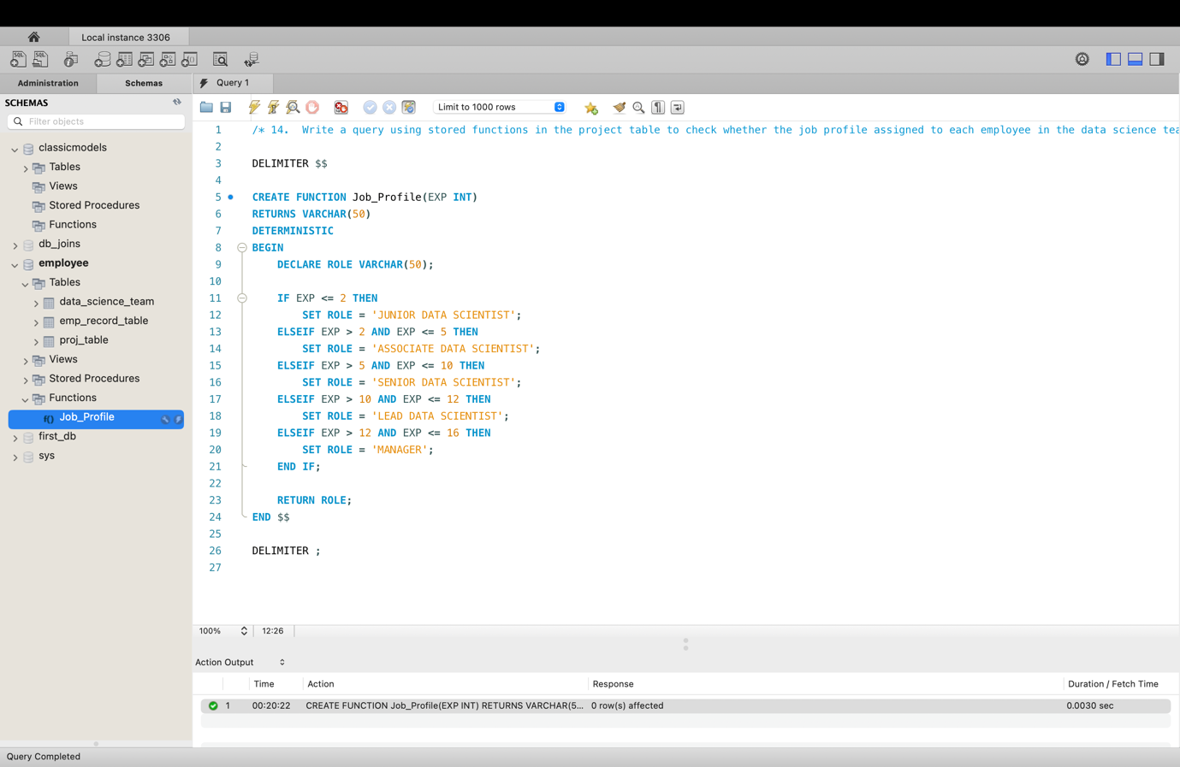

SELECT

EMP_ID,

FIRST_NAME,

LAST_NAME,

EXP,

ROLE AS Assigned_Role,

JOB_PROFILE(EXP) AS Expected_role,

CASE

WHEN ROLE = JOB_PROFILE(EXP) THEN 'MATCHED'

ELSE 'NOT MATCHED'

END AS Role_Status

FROM

data_science_team;

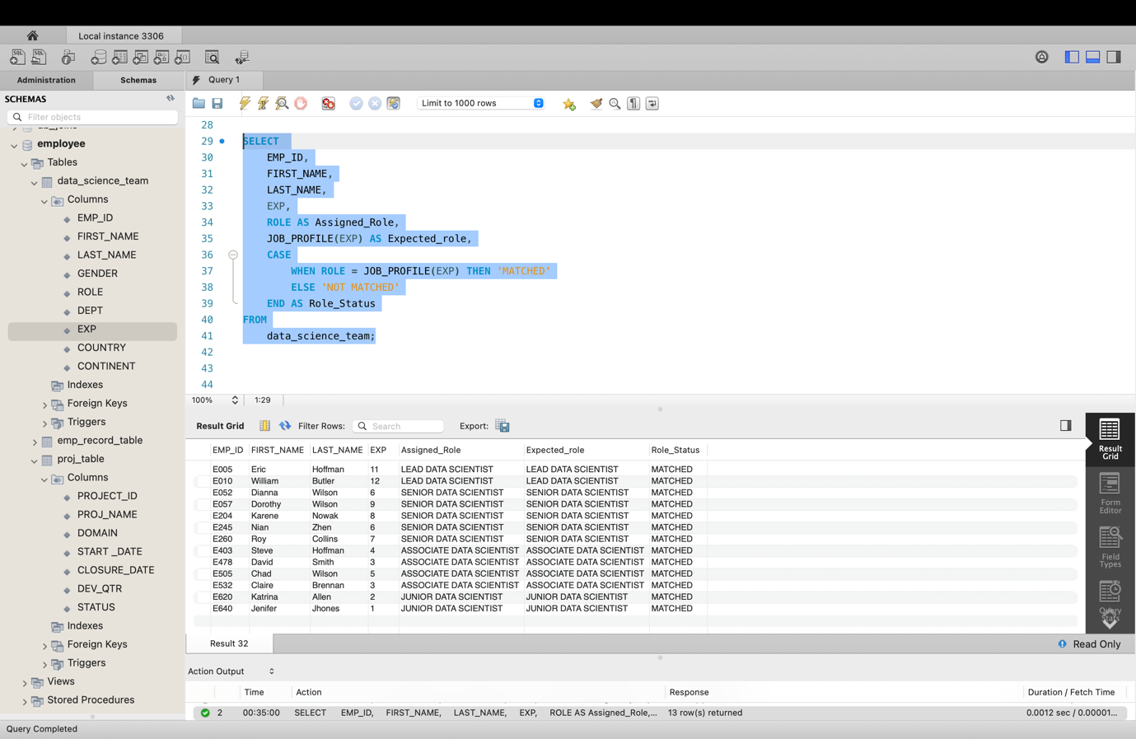

1. **Create an index to improve the cost and performance of the query to find the employee whose FIRST_NAME is ‘Eric’ in the employee table after checking the execution plan.**

**Query –**

**Check Execution Plan (Before Index)**

SELECT *

FROM emp_record_table

WHERE FIRST_NAME = 'Eric';

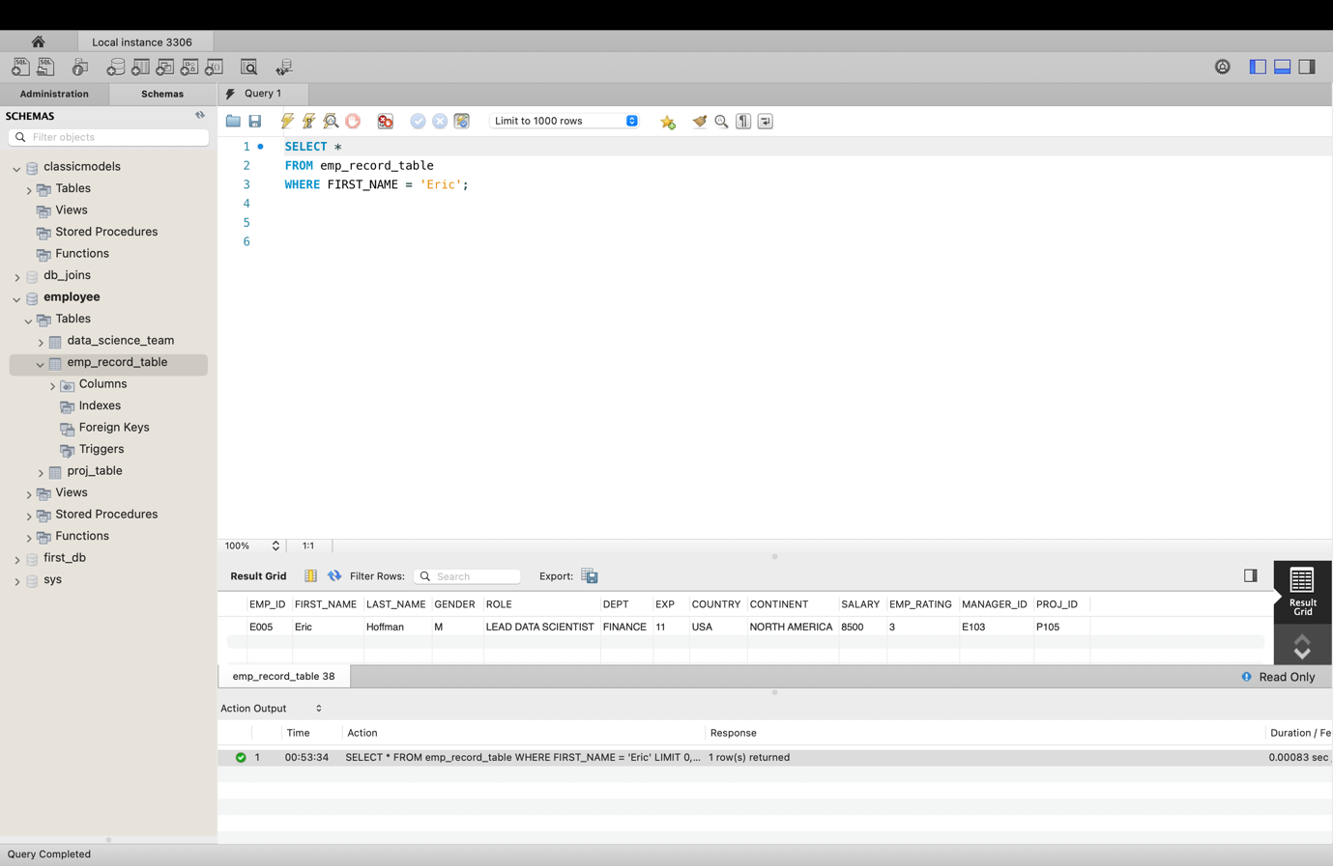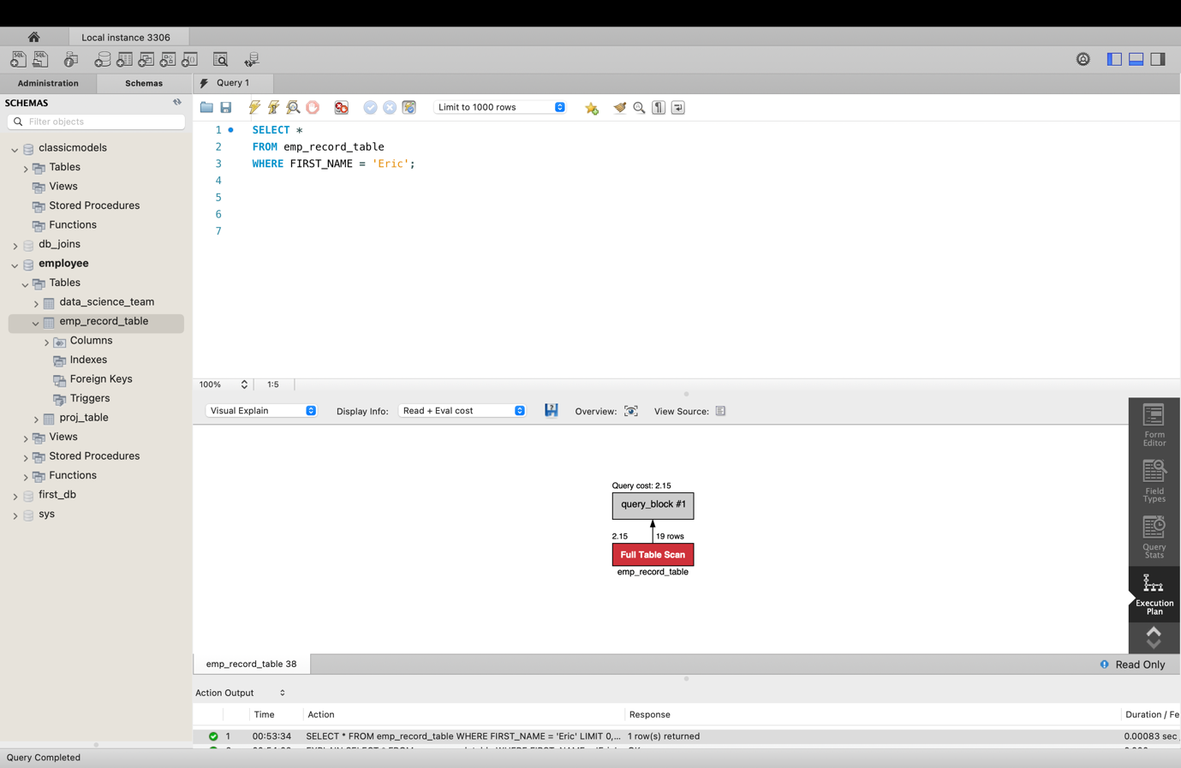

**Create Index**

CREATE INDEX idx_first_name

ON emp_record_table (FIRST_NAME(20));

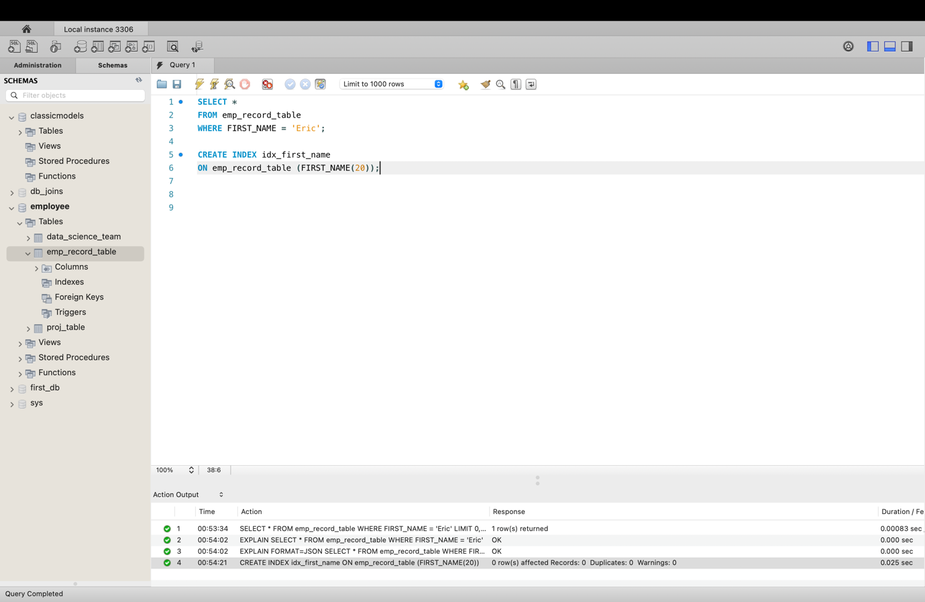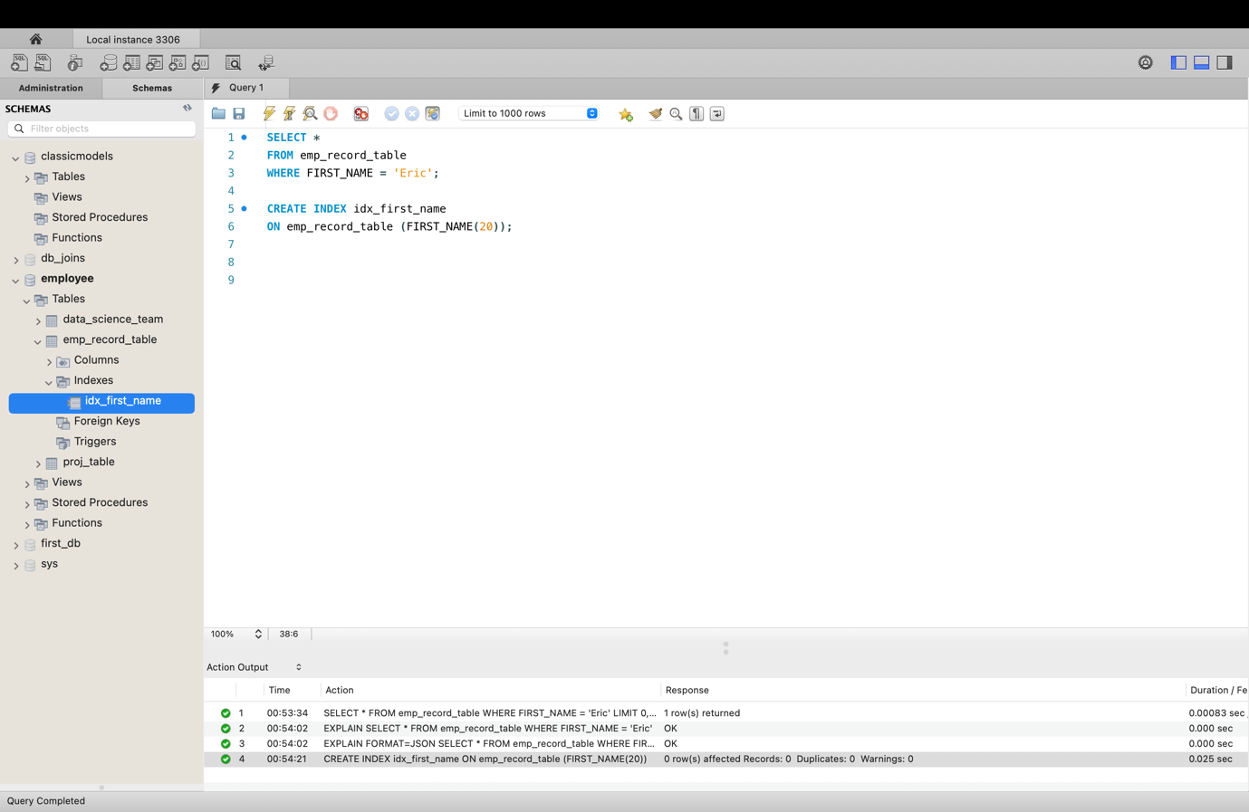

**Check Execution Plan Again (After Index)**

SELECT *

FROM emp_record_table

WHERE FIRST_NAME = 'Eric';

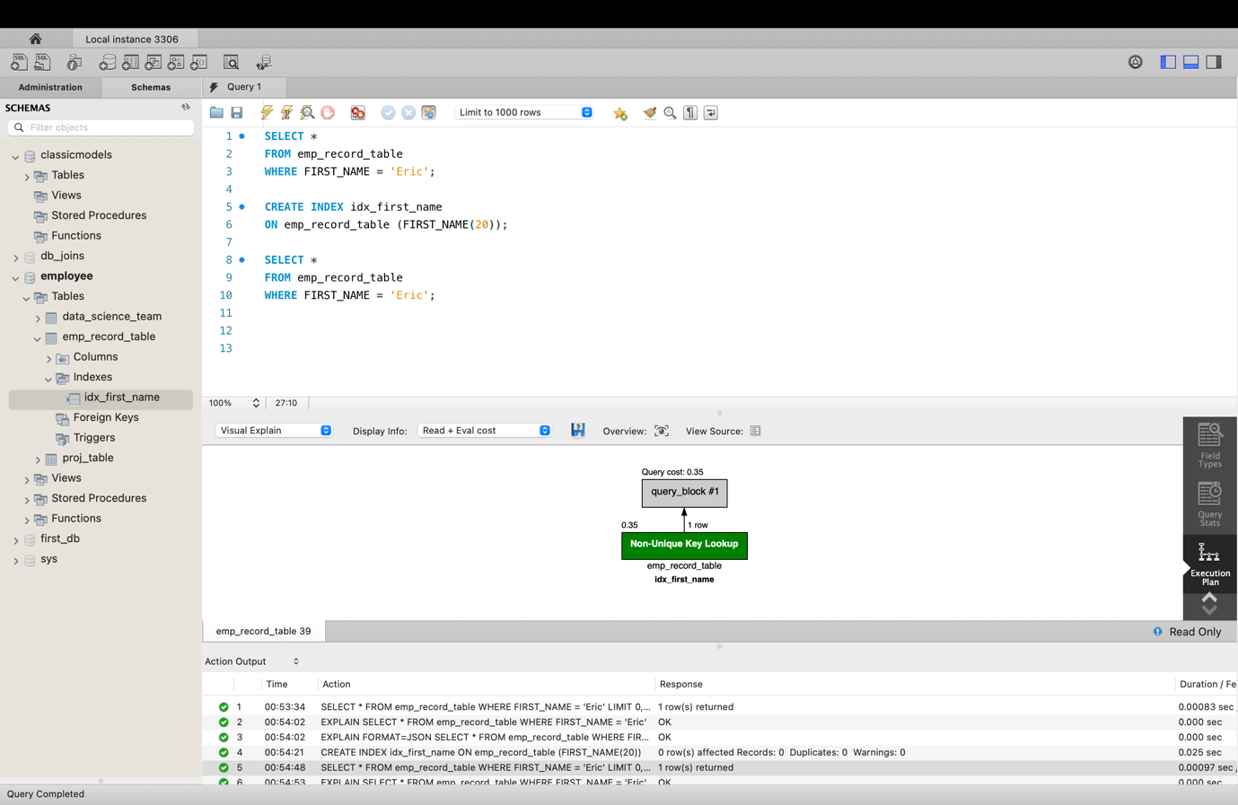

1. **Write a query to calculate the bonus for all the employees, based on their ratings and salaries (Use the formula: 5% of salary * employee rating).**

**Query –**

SELECT

EMP_ID,

CONCAT(TRIM(FIRST_NAME), ' ', TRIM(LAST_NAME)) AS 'EMP_NAME',

SALARY,

EMP_RATING,

(SALARY * 0.05 * EMP_RATING) AS Bonus

FROM

emp_record_table;

**Output –**

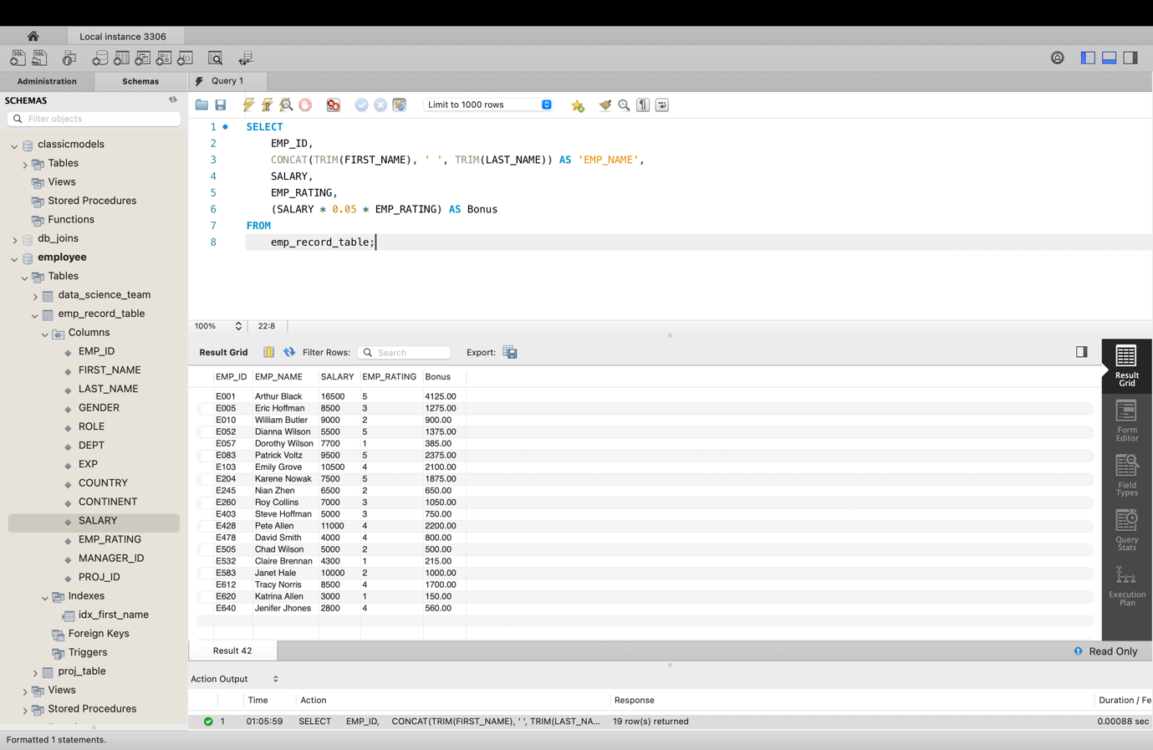

1. **Write a query to calculate the average salary distribution based on the continent and country. Take data from the employee record table.**

**Query –**

SELECT

CONTINENT, COUNTRY, AVG(SALARY) AS AVG_SALARY

FROM

emp_record_table

GROUP BY CONTINENT , COUNTRY;

**Output –**

